**TOP VIEW**

**BACK SIDE VIEW**

**FRONT VIEW**

**HOME VIEW**

**PROJECT VIEW**

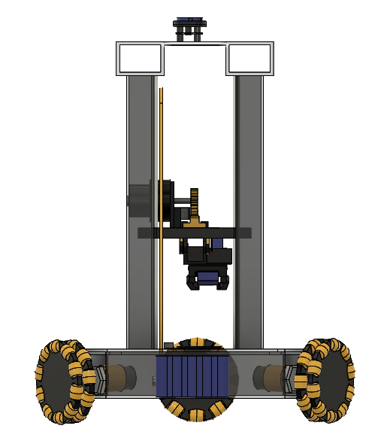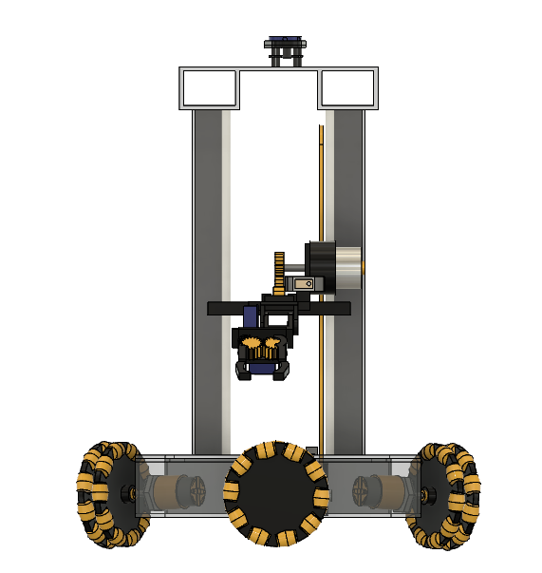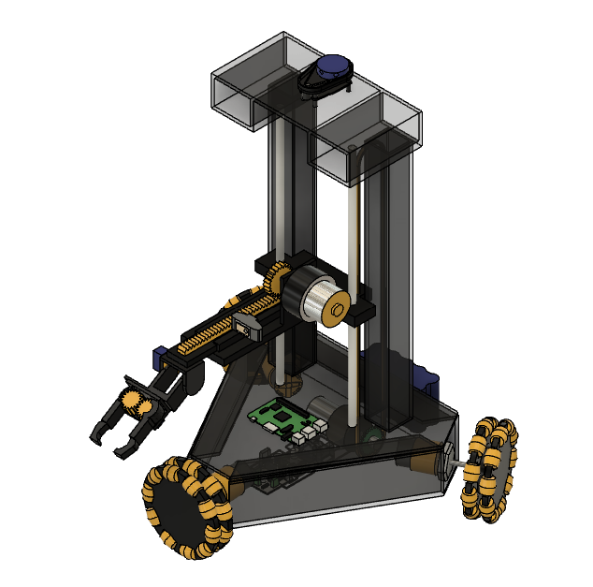`

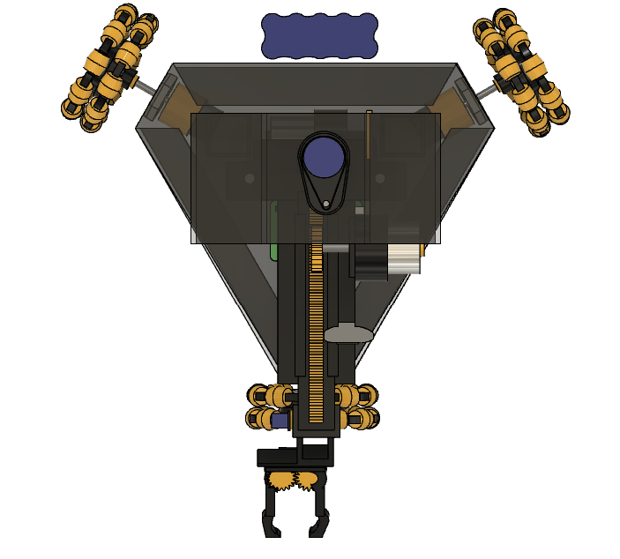

**DIAGNOAL VIEW**

**CHAIN DRIVE MECHANISM**

**INTERNAL VIEW**

**SIDE VIEW**

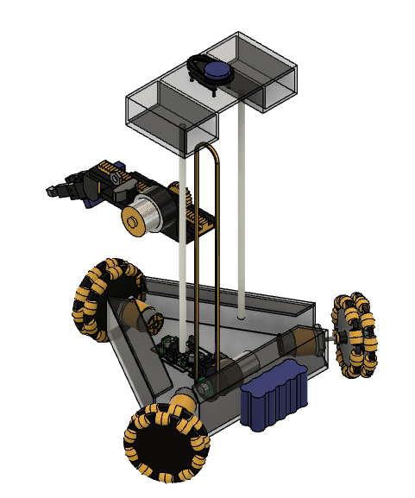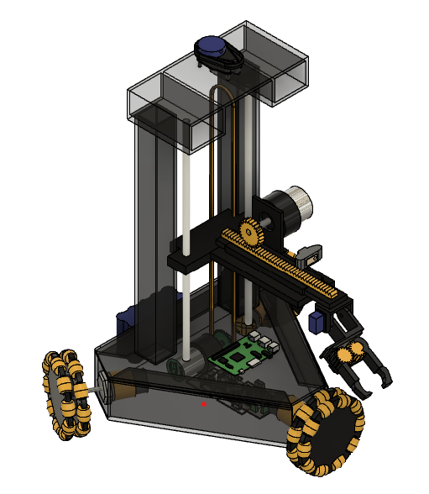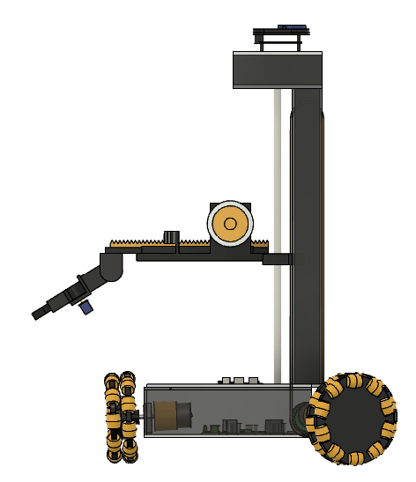 `

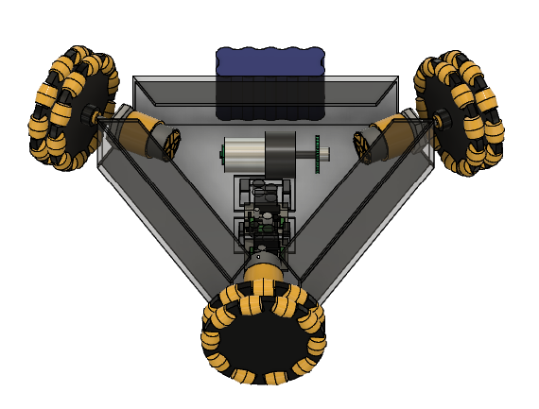

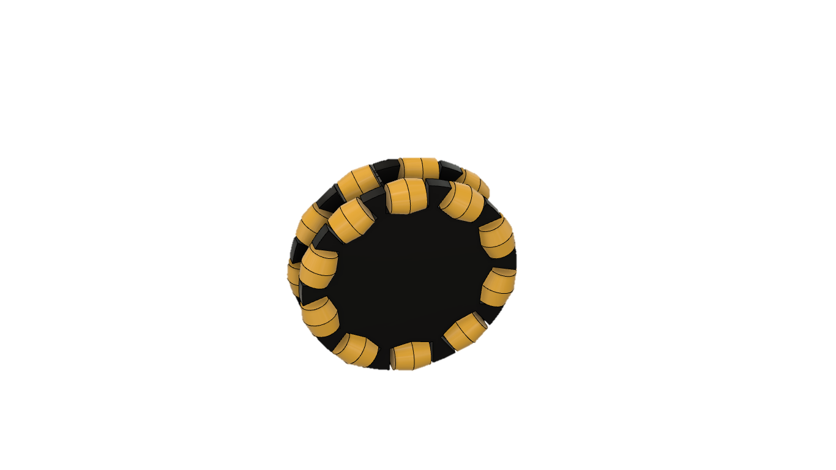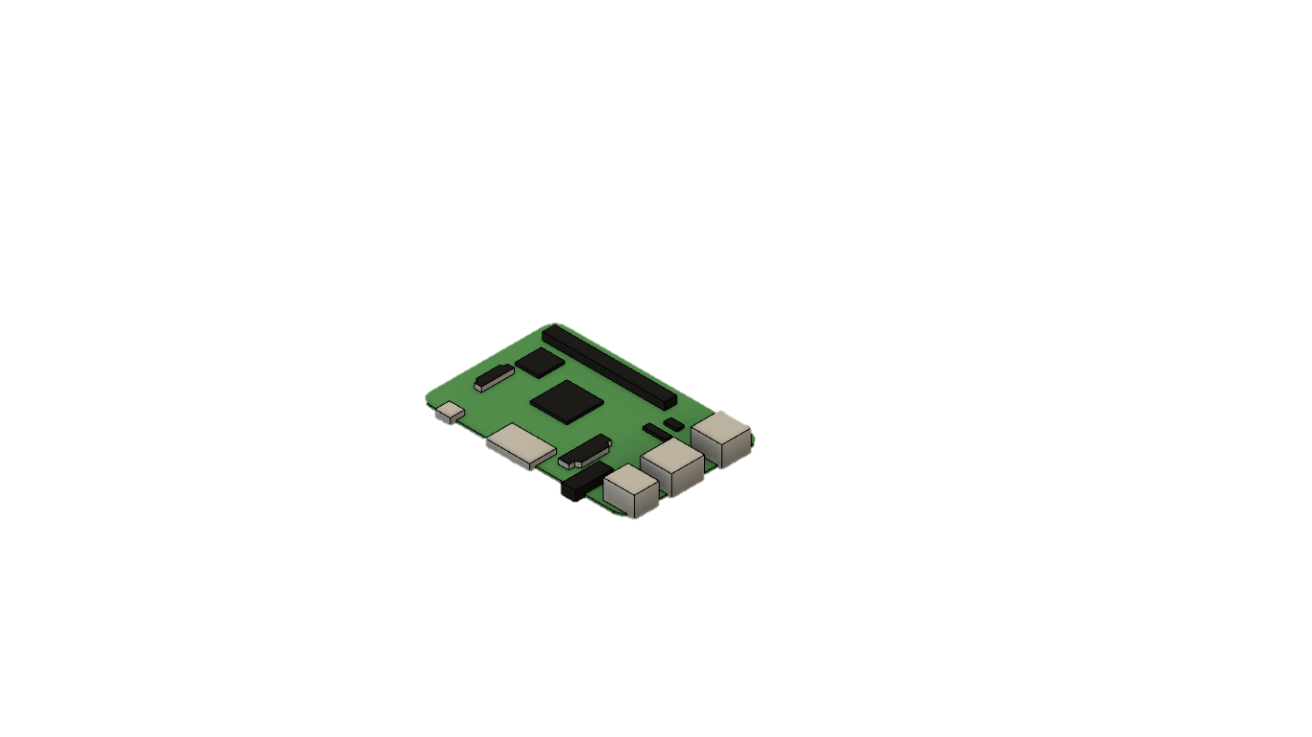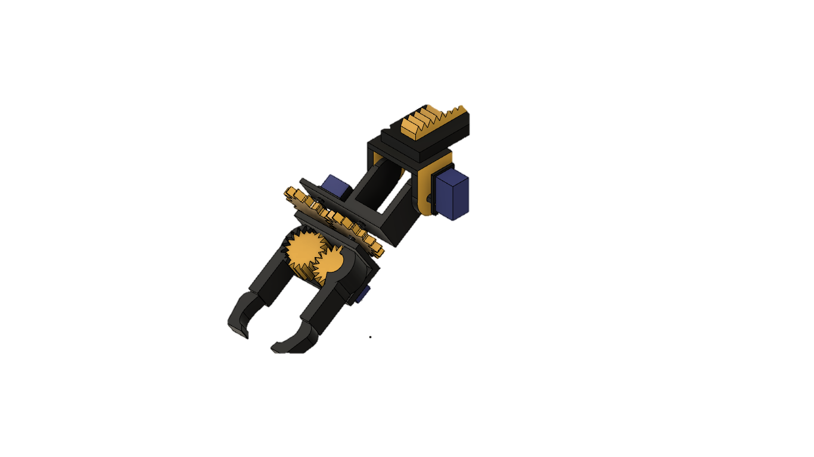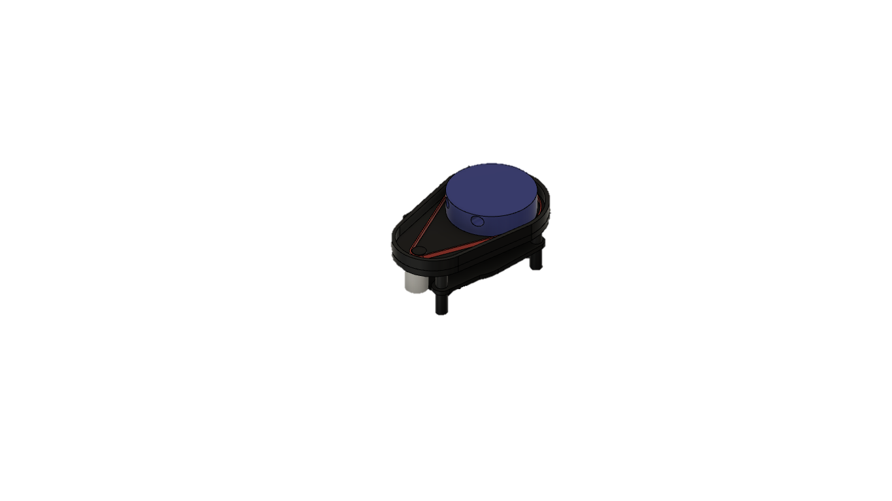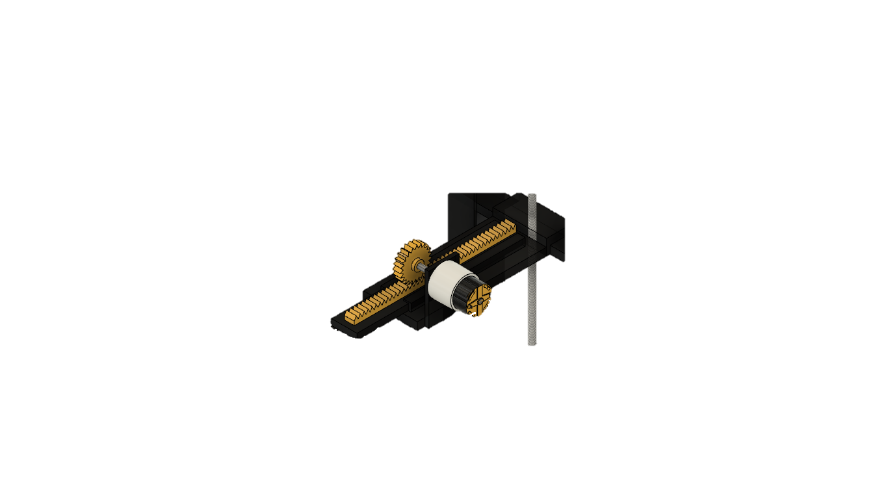

**COMPONENTS USED IN THE ROBOT**

LIDAR SENSOR

SERVO GRIPPER

RACK AND PINION MECHANISM

RASPBERRY PI

OMNI WHEELS

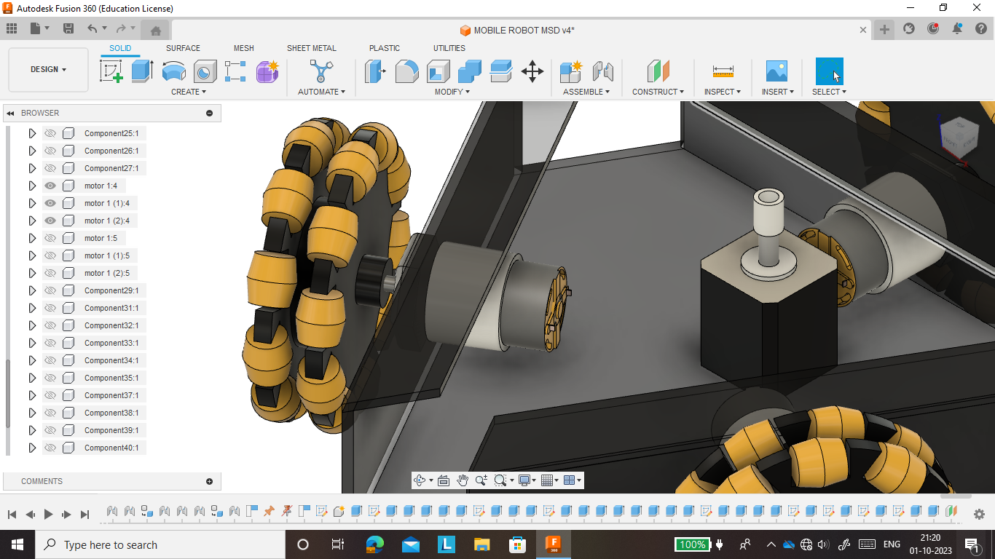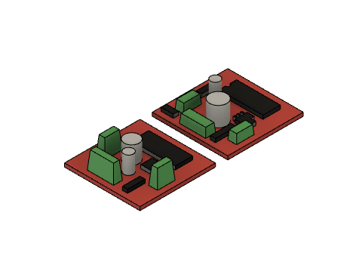

L293D MOTOR DRIVER

JHONSON GEAR MOTOR

JHONSON GEAR MOTOR



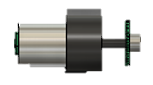



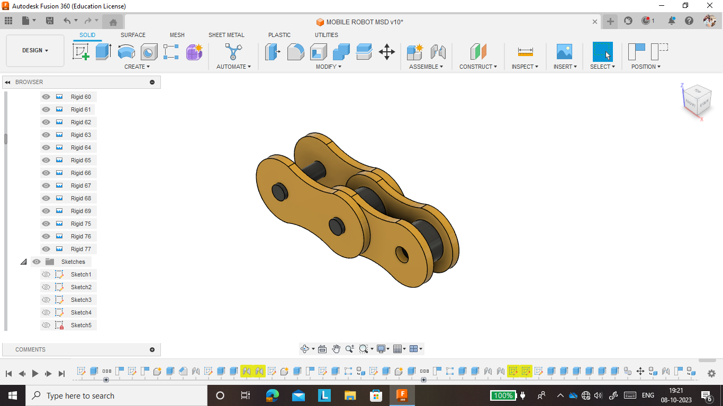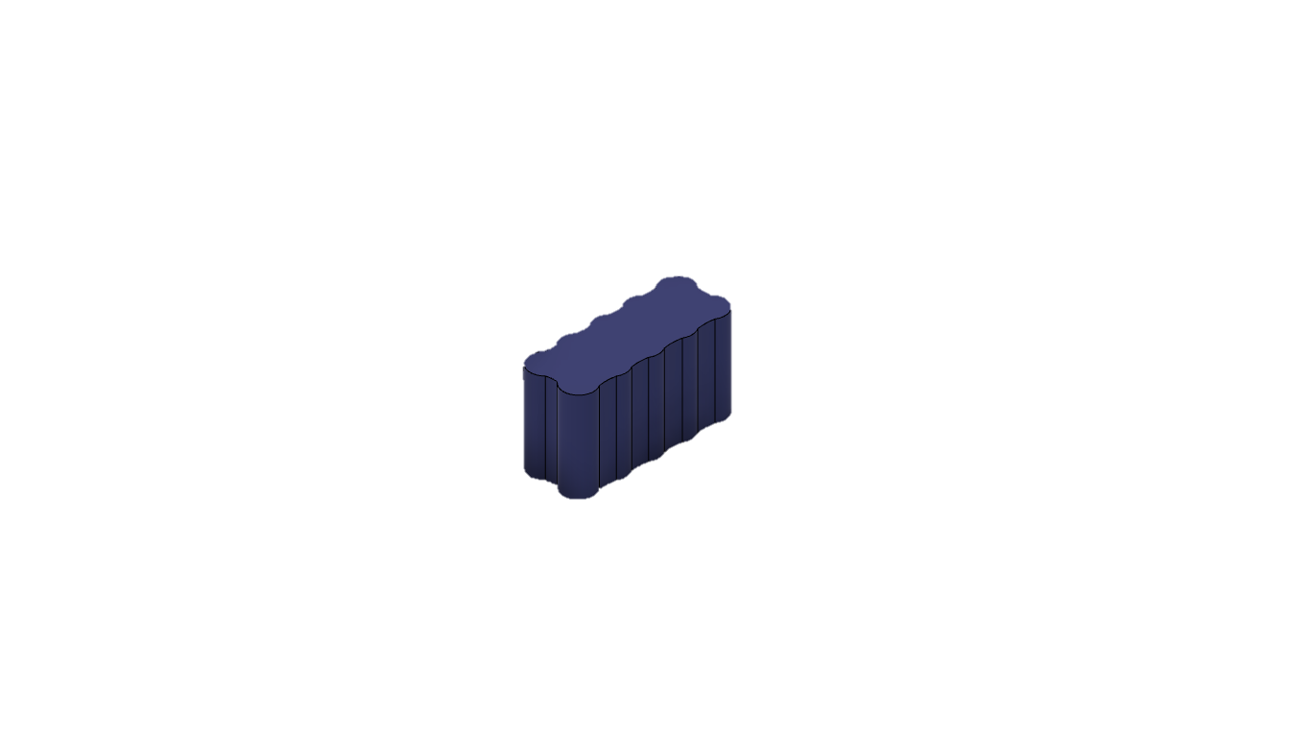

BATTERY

CAMERA

SERVO MOTORS

CHAIN DRIVE

